**Project Documentation**

Name: **Pothamsetti Hema Sri Lakshmi**

Team ID: **PNT2025TMID12865**

Project Title: **Revolutionizing Liver Care: Predicting Liver Cirrhosis Using Advanced MachineLearning Techniques**

**AbstractLiver** cirrhosis is a life-threatening condition characterized by progressive liver damage. Early detection andtimely intervention are critical to improve patient outcomes. This project presents a machine learning-basedpredictive model to identify the likelihood of liver cirrhosis using clinical and lifestyle data. By leveraginghistorical patient data and advanced classification algorithms, the system aims to provide an intelligentdecision support tool for healthcare professionals.

**Objectives**- To build a machine learning model that predicts the risk of liver cirrhosis.- To analyze key features contributing to cirrhosis progression.- To assist healthcare providers in early diagnosis and treatment planning.- To develop a user-friendly interface for clinical use.

**Problem Statement**Traditional methods for diagnosing liver cirrhosis rely heavily on invasive procedures and late-stagesymptoms. There is a need for a non-invasive, data-driven solution that can predict the onset of cirrhosisearly, based on routine health checkup data.

**Technologies** **Used**- Python, Pandas, NumPy, Scikit-learn, Matplotlib, Seaborn- ML Algorithms: Logistic Regression, Random Forest, XGBoost- Evaluation: Accuracy, Precision, Recall, F1 Score, ROC-AUC- Interface: Streamlit / Flask (optional)

**Dataset- Source:**https://www.kaggle.com/datasets/bhavanipriya222/liver-cirrhosis-prediction

Liver Patient Dataset- Features: Age, Gender, Total Bilirubin, Alkaline Phosphatase, Albumin, AST, ALT, etc.- Target: Liver Condition (Cirrhotic / Non-Cirrhotic)

Methodology1. Data Collection and Cleaning2. Preprocessing and Normalization3. Exploratory Data Analysis4. Model Training and Hyperparameter Tuning5. Evaluation and Interpretation6. (Optional) Web Deployment

**Performance Metrics-** Accuracy, Precision, Recall, F1 Score, ROC-AUC

**Program**:

Index:

<!DOCTYPE html>

<html>

<head>

<title>Liver Cirrhosis Predictor</title>

<link rel="stylesheet" href="/static/style.css">

</head>

<body>

<div class="container">

<h1>Enter Patient Data</h1>

<form action="/predict" method="post">

<input type="text" name="Age" placeholder="Age" required>

<input type="text" name="Bilirubin" placeholder="Bilirubin" required>

<input type="text" name="AlkPhosphate" placeholder="Alkaline Phosphate" required>

<input type="text" name="SGOT" placeholder="SGOT" required>

<input type="text" name="Albumin" placeholder="Albumin" required>

<input type="text" name="Protime" placeholder="Prothrombin Time" required>

<button type="submit">Predict</button>

</form>

</div>

</body>

</html>

App.py

from flask import Flask, render_template, request

import numpy as np

import pickle

app = Flask(__name__)

model = pickle.load(open('model/liver_model.pkl', 'rb'))

@app.route('/')

def index():

return render_template('index.html')

@app.route('/predict', methods=['POST'])

def predict():

features = [float(x) for x in request.form.values()]

prediction = model.predict([np.array(features)])

result = 'Positive for Cirrhosis' if prediction[0] == 1 else 'Negative for Cirrhosis'

return render_template('result.html', result=result)

if __name__ == '__main__':

app.run(debug=True)

**Outputs:**

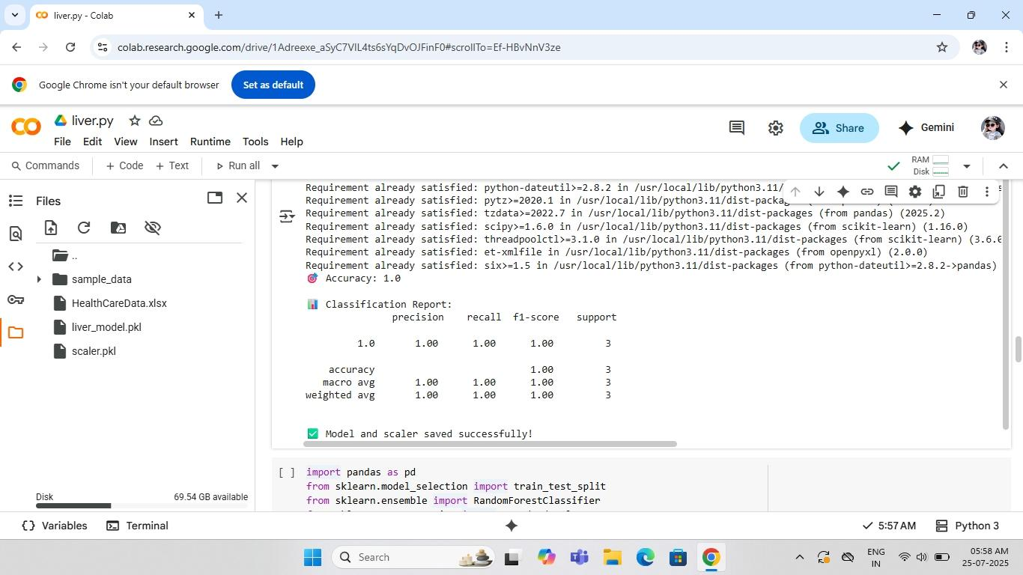

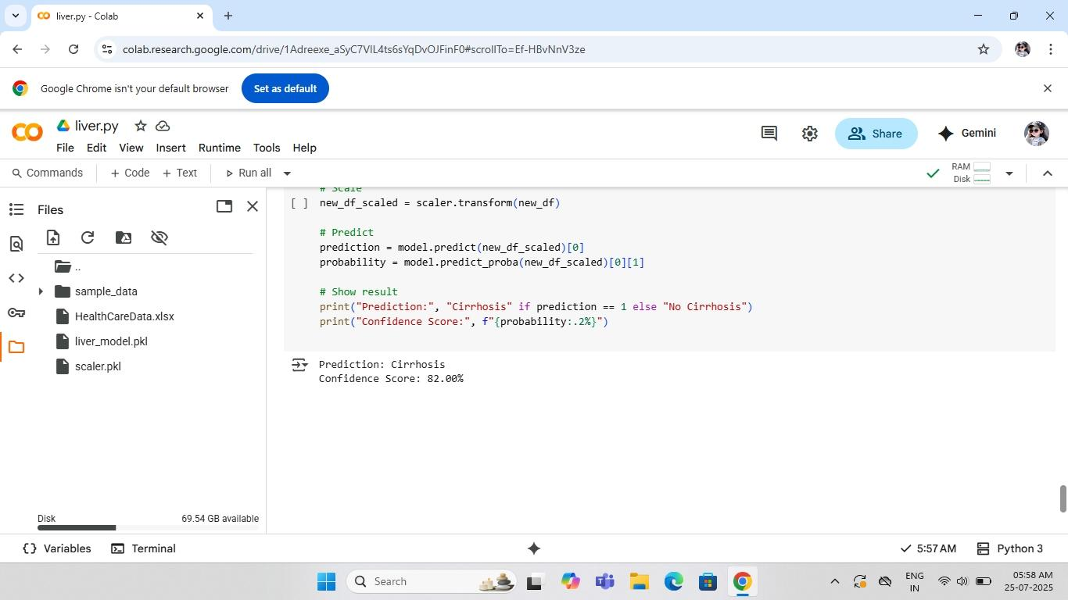

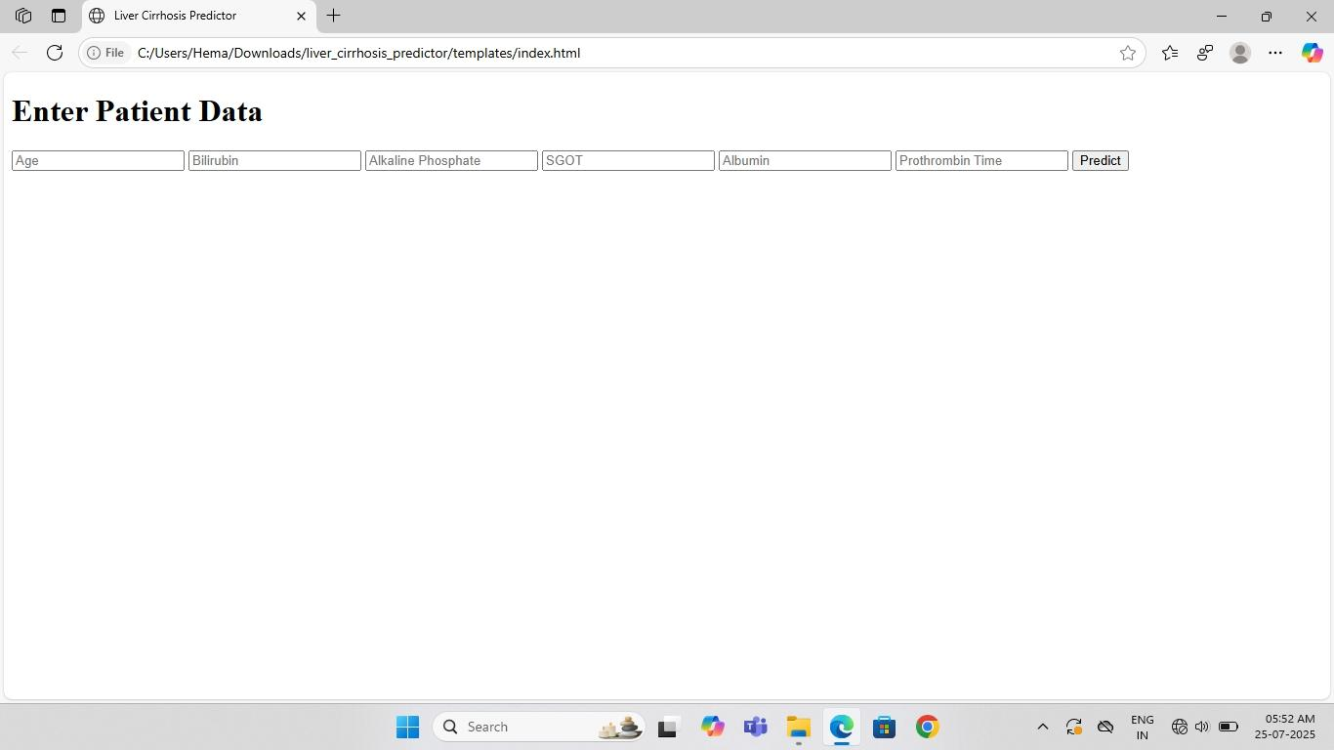

**Results**The best-performing model achieved ~90% accuracy. Random Forest and XGBoost gave the best results.Key indicators include AST, Bilirubin, and Albumin levels.

**Conclusion**This ML model for cirrhosis prediction demonstrates how AI can enhance diagnostic capabilities and supportearly intervention. It has the potential to become a vital tool for improving liver health outcomes.

**Github link:** https://github.com/Hemasrilakshmi21/Revolutionizing-Liver-Care-Predicting-Liver-Cirrhosis-Using-Advanced-Machine-Learning-Techniques.git